

***Lebanese International University***

***School of Engineering***

Department of Electrical Engineering

CENG352L— Electronics Lab

Section ID: B

Report ID: Electronics Project

Project Title: Siren

**(5 points)**

Submitted by: Fadi Abou Fakhr - 11320018

Click here to enter text.

Lab Instructor: Ali Mohsen

Date: 23/5/2017

**(5 points)**

# Objectives of the Experiment (20 points)

To understand transistir applications

# Equipment used in this Experiment (10 Points)

-1k, 27k, and 47k resistors

-BC547 and BC557 transistors

-A speaker

-DC power supply

-100u and 100n capacitors

# Experiment I (10 Points)

## Description of Experiment I

This circuit produces a wailing or siren sound that gradually increases and decreases in frequency as the 100u charges and discharges when the push-button is pressed and released.  In other words, the circuit is not automatic. You need to press the button and release it to produce the up/down sound.

## Procedure of Experiment I

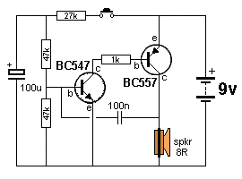fig1

Connect the circuit according to fig1, push the button to produce the siren sound, push again to turn it off.

## Results

Once the button is pushed, the speaker produces a siren like sound, on second press the sound stops.

# Experiment II (10 Points)

## Description of Experiment II

Click here to enter text.

## Procedure of Experiment II

Click here to enter text.

## Results

Click here to enter text.

# Experiment III (10 Points)

## Description of Experiment III

Click here to enter text.

## Procedure of Experiment III

Click here to enter text.

## Results

Click here to enter text.

# Experiment IV (10 Points)

## Description of Experiment IV

.

## Procedure of Experiment IV

Click here to enter text.

## Results

Click here to enter text.

# Conclusion (20 Points)

* Click here to enter text.
* Click here to enter text.
* Click here to enter text.
* Click here to enter text.
* Click here to enter text.

Click here to enter text.